Program:1
#include<stdio.h>
#include<stdlib.h>
int main ()
{
int n=5, *a;
a=(int*) malloc(n*sizeof(int));
int i;
for(i=0;i<n;i++)
{
a[i]=0;
printf("%d",a[i]);
}
printf("program output:success\n");
system("getmac");
return 0;
}
Output:
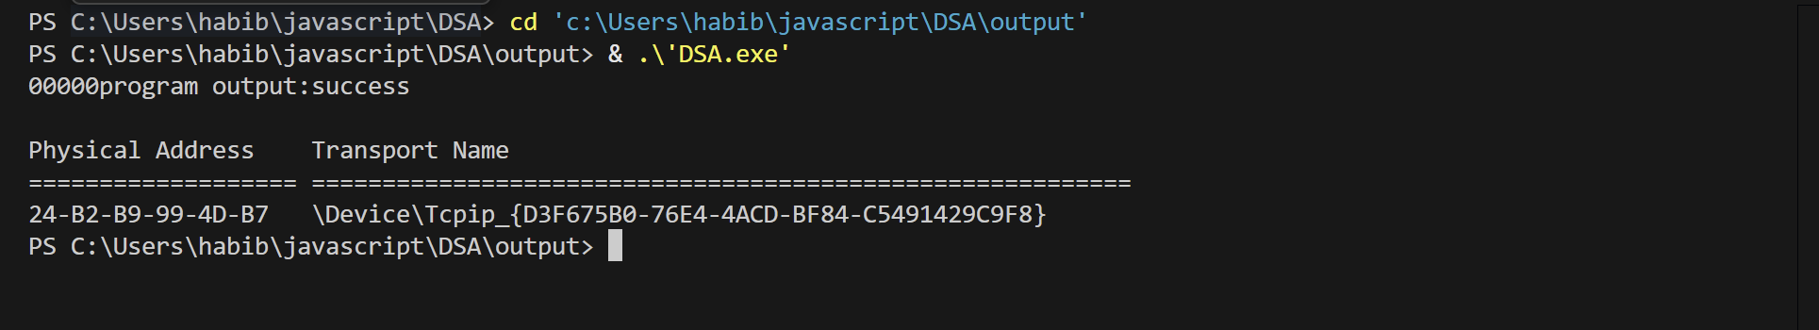

Program:2
#include <stdio.h>
#include <stdlib.h>
int main()
{
int *p = (int *)malloc(sizeof(int));
printf("%p\n", (void *)p);
free(p);
system("getmac");
return 0;
}
Output:
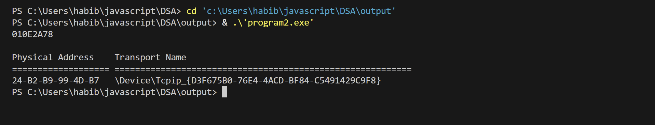

Program:3
#include <stdio.h>
#include <stdlib.h>
int main() {
int n, i, j, t, *a;
scanf("%d", &n);
a = (int *)malloc(n * sizeof(int));
for (i = 0; i < n; i++) scanf("%d", &a[i]);
for (i = 0; i < n - 1; i++)
for (j = i + 1; j < n; j++)
if (a[i] > a[j]) {
t = a[i];
a[i] = a[j];
a[j] = t;
}
for (i = 0; i < n; i++) printf("%d ", a[i]);
free(a);
system("getmac");
return 0;
}
Output:
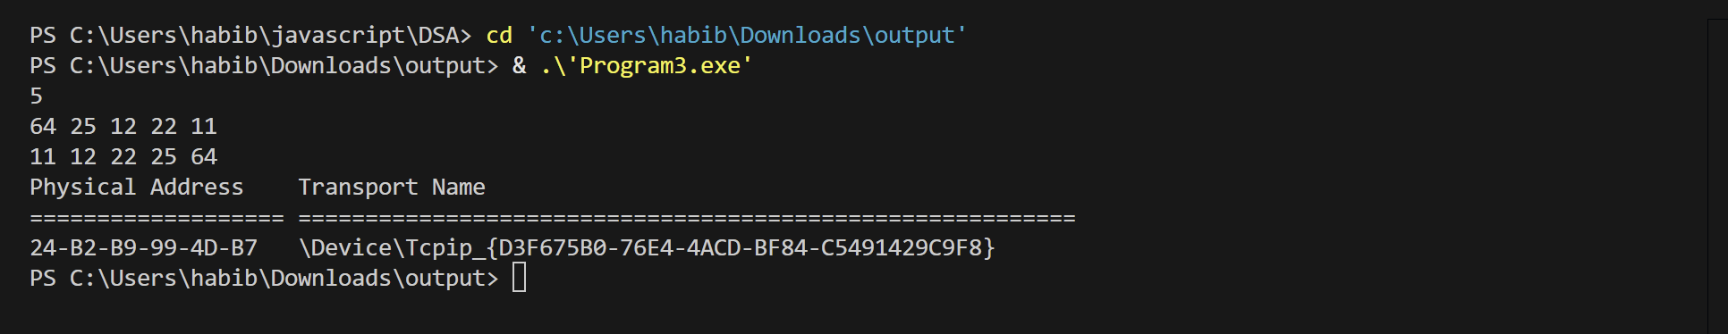

Program:4
#include <stdio.h>
int main() {
int n, i, j, t, a[100];
scanf("%d", &n);
for (i = 0; i < n; i++) scanf("%d", &a[i]);
for (i = 0; i < n - 1; i++)
for (j = i + 1; j < n; j++)
if (a[i] > a[j]) {
t = a[i];
a[i] = a[j];
a[j] = t;
}
for (i = 0; i < n; i++) printf("%d ", a[i]);
system("getmac");
return 0;
}
Output:
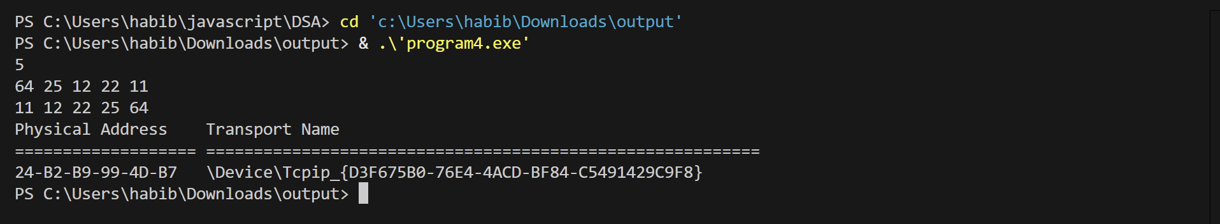

Program:5
#include <stdio.h>
#include <stdlib.h>
int main() {
int r, c, i, j;
int **a;
scanf("%d %d", &r, &c);
a = (int **)malloc(r * sizeof(int *));
for (i = 0; i < r; i++)
a[i] = (int *)malloc(c * sizeof(int));
for (i = 0; i < r; i++)
for (j = 0; j < c; j++)
scanf("%d", &a[i][j]);
for (i = 0; i < r; i++) {
for (j = 0; j < c; j++)
printf("%d ", a[i][j]);
printf("\n");
}
for (i = 0; i < r; i++) free(a[i]);
free(a);
system("getmac");
return 0;
}
Output:
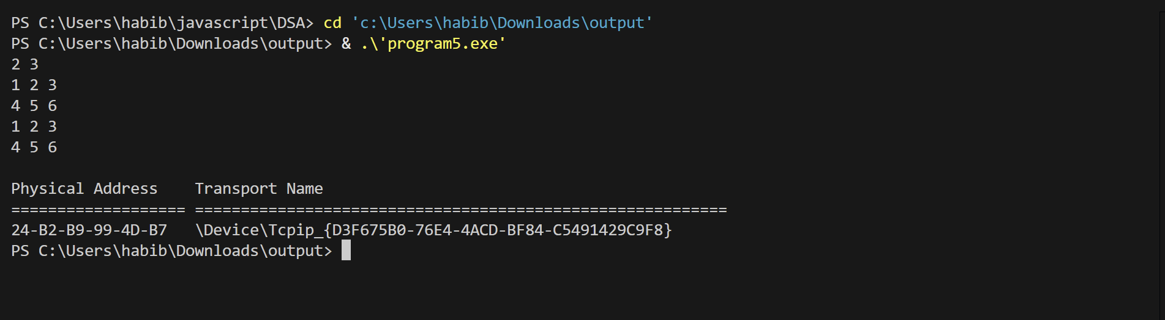
Program:6
#include <stdio.h>
#include <string.h>
int main() {
char t[100], p[50];
int i, j;
scanf("%s", t);
scanf("%s", p);
for (i = 0; i <= strlen(t) - strlen(p); i++) {
for (j = 0; j < strlen(p); j++)
if (t[i + j] != p[j])
break;
if (j == strlen(p))
printf("Pattern found at position %d\n", i);
}
system("getmac");
return 0;
}
Output:
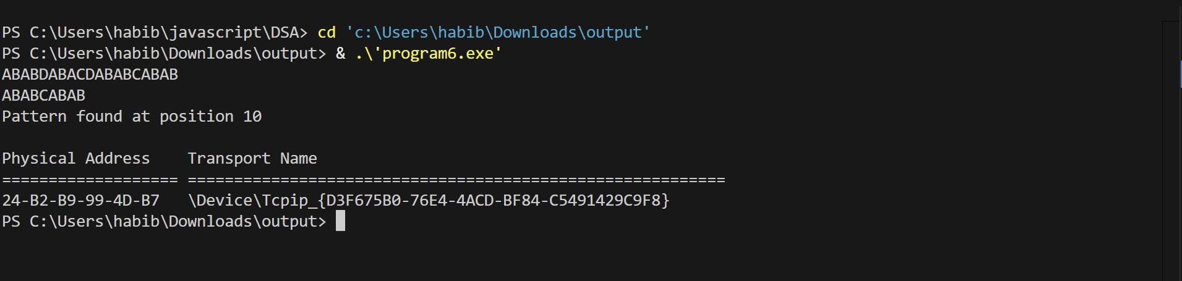

Program:7
#include <stdio.h>
#include <stdlib.h>
struct node {
int data;
struct node *next;
};
int main() {
struct node *n1, *n2;
n1 = (struct node *)malloc(sizeof(struct node));
n2 = (struct node *)malloc(sizeof(struct node));
printf("Enter first node data: ");
scanf("%d", &n1->data);
printf("Enter second node data: ");
scanf("%d", &n2->data);
n1->next = n2;
n2->next = NULL;
printf("Linked list data:\n");
printf("%d -> %d -> NULL", n1->data, n1->next->data);
free(n1);
free(n2);
system("getmac");
return 0;
}
Output:
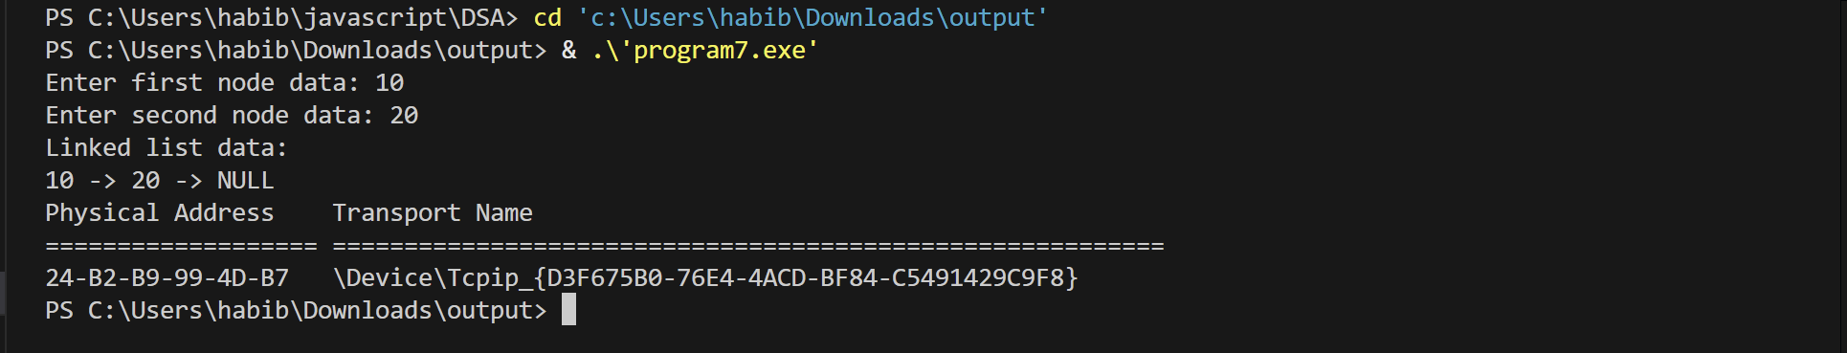

Program:8
#include <stdio.h>
int main() {
int a, b;
printf("Enter a number: ");
scanf("%d", &a);
b = a;
printf("Pre-increment (++a): %d\n", ++a);
printf("Post-increment (b++): %d\n", b++);
printf("Final values:\n");
printf("a = %d\n", a);
printf("b = %d\n", b);
system("getmac");
return 0;
}
Output:
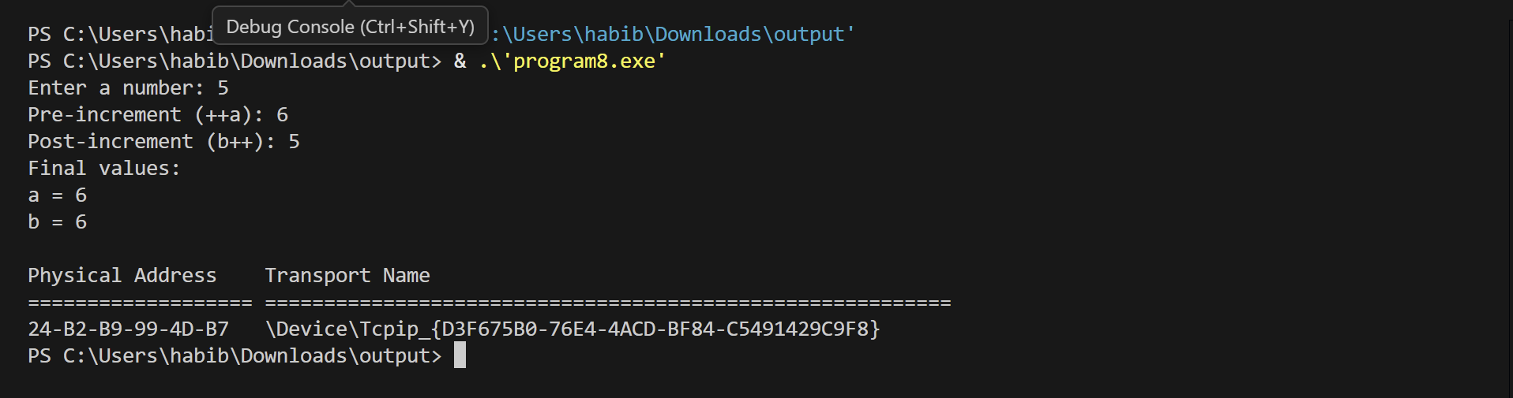

Program:9
#include <stdio.h>
int main() {
int a, b;
printf("Enter a number: ");
scanf("%d", &a);
b = a;
printf("Pre-decrement (--a): %d\n", --a);
printf("Post-decrement (b--): %d\n", b--);
printf("Final values:\n");
printf("a = %d\n", a);
printf("b = %d\n", b);
system("getmac");
return 0;
}
Output:
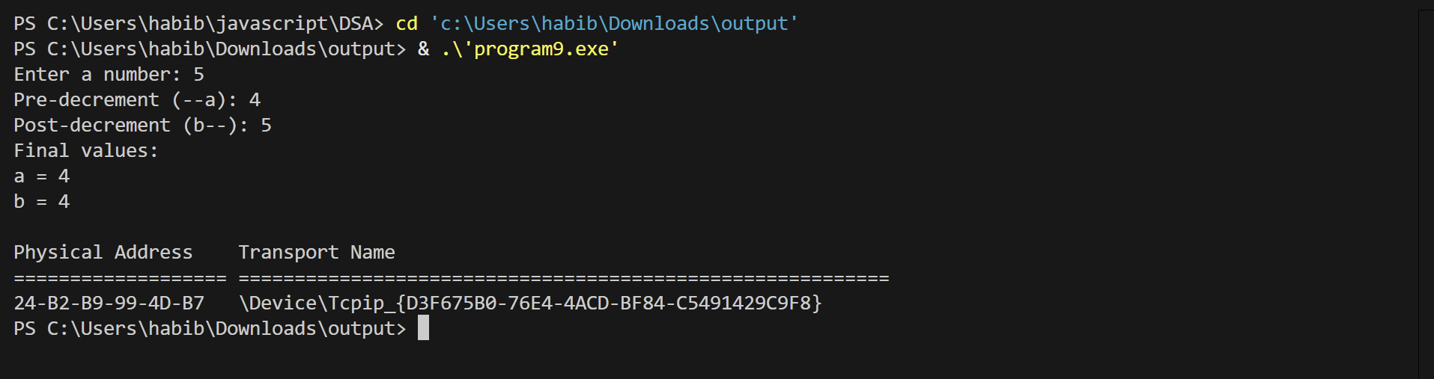

Program:10
#include <stdio.h>
#define SIZE 5
int queue[SIZE];
int front = -1, rear = -1;
void enqueue(int x) {
if (rear == SIZE - 1)
printf("Queue Overflow\n");
else {
if (front == -1) front = 0;
queue[++rear] = x;
}
}
void dequeue() {
if (front == -1 || front > rear)
printf("Queue Underflow\n");
else
printf("Deleted element: %d\n", queue[front++]);
}
void display() {
int i;
if (front == -1 || front > rear)
printf("Queue is empty\n");
else {
printf("Queue elements: ");
for (i = front; i <= rear; i++)
printf("%d ", queue[i]);
printf("\n");
}
}
int main() {
int ch, x;
do {
printf("\n1.Enqueue 2.Dequeue 3.Display 4.Exit\n");
scanf("%d", &ch);
switch (ch) {
case 1:
printf("Enter element: ");
scanf("%d", &x);
enqueue(x);
break;
case 2:
dequeue();
break;
case 3:
display();
break;
}
}
while (ch != 4);
system("getmac");
return 0;
}
Output:
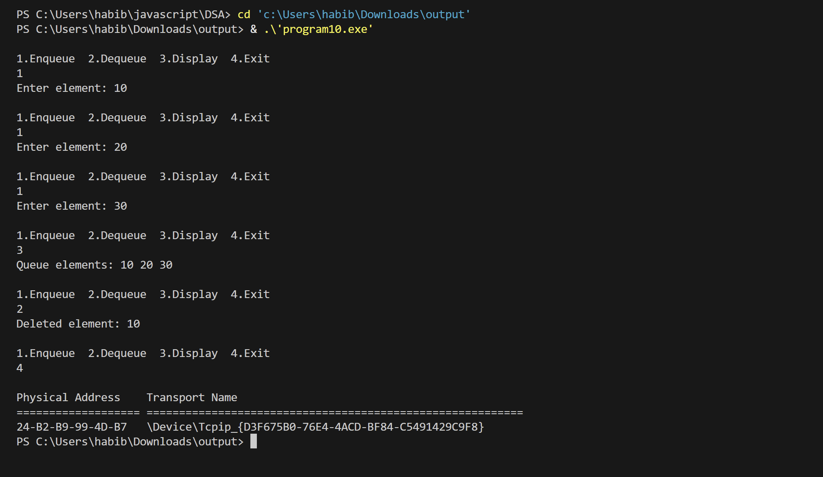

Program:11
#include <stdio.h>
#include <stdlib.h>
struct node {
int data;
struct node *next;
};
struct node *head = NULL;
void insert(int x) {
struct node *new = (struct node *)malloc(sizeof(struct node));
struct node *temp = head;
new->data = x;
new->next = NULL;
if (head == NULL)
head = new;
else {
while (temp->next != NULL)
temp = temp->next;
temp->next = new;
}
}
void delete(int x) {
struct node *temp = head, *prev = NULL;
if (head == NULL) {
printf("List is empty\n");
return;
}
if (head->data == x) {
head = head->next;
free(temp);
return;
}
while (temp != NULL && temp->data != x) {
prev = temp;
temp = temp->next;
}
if (temp == NULL)
printf("Element not found\n");
else {
prev->next = temp->next;
free(temp);
}
}
void display() {
struct node *temp = head;
if (head == NULL) {
printf("List is empty\n");
return;
}
printf("Linked List: ");
while (temp != NULL) {
printf("%d -> ", temp->data);
temp = temp->next;
}
printf("NULL\n");
}
int main() {
int ch, x;
do {
printf("\n1.Insert 2.Delete 3.Display 4.Exit\n");
scanf("%d", &ch);
switch (ch) {
case 1:
printf("Enter value: ");
scanf("%d", &x);
insert(x);
break;
case 2:
printf("Enter value to delete: ");
scanf("%d", &x);
delete(x);
break;
case 3:
display();
break;
}
} while (ch != 4);
system("getmac");
return 0;
}
Output:
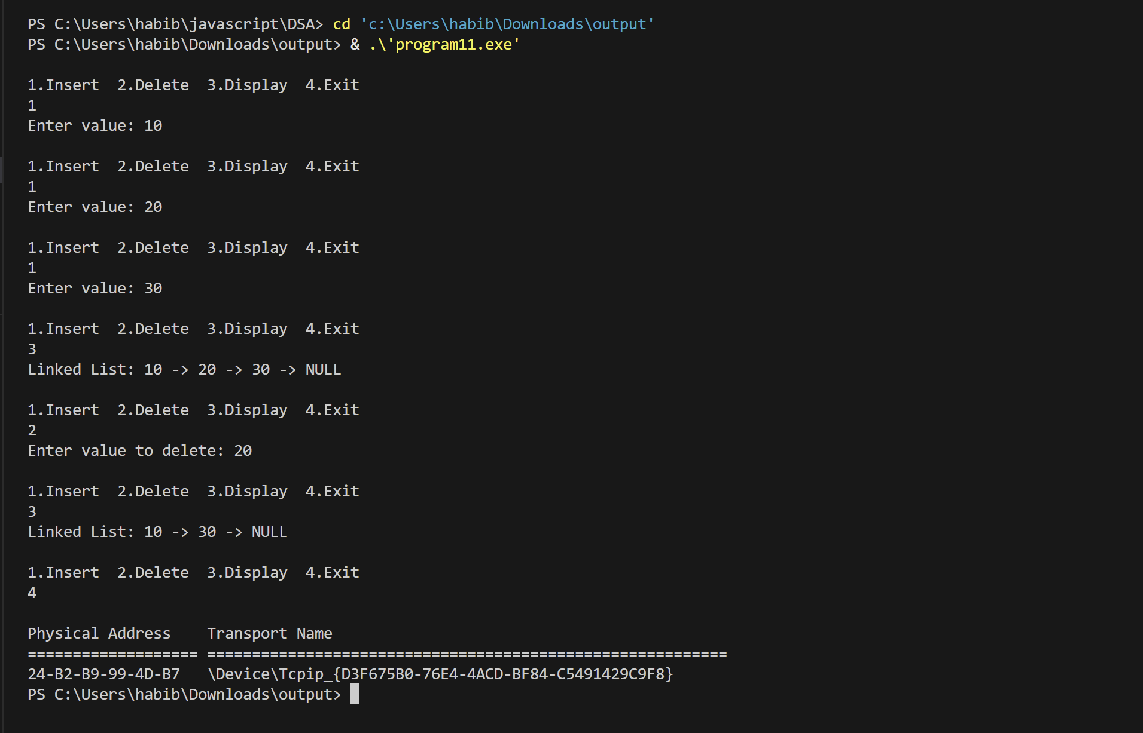

Program:12
#include <stdio.h>
#include <stdlib.h>
struct node {
int data;
struct node *next;
};
struct node *top = NULL;
void push(int x) {
struct node *new = (struct node *)malloc(sizeof(struct node));
new->data = x;
new->next = top;
top = new;
}
void pop() {
struct node *temp;
if (top == NULL) {
printf("Stack Underflow\n");
return;
}
temp = top;
printf("Popped element: %d\n", temp->data);
top = temp->next;
free(temp);
}
void display() {
struct node *temp = top;
if (top == NULL) {
printf("Stack is empty\n");
return;
}
printf("Stack elements:\n");
while (temp != NULL) {
printf("%d\n", temp->data);
temp = temp->next;
}
}
int main() {
int ch, x;
do {
printf("\n1.Push 2.Pop 3.Display 4.Exit\n");
scanf("%d", &ch);
switch (ch) {
case 1:
printf("Enter element: ");
scanf("%d", &x);
push(x);
break;
case 2:
pop();
break;
case 3:
display();
break;
}
} while (ch != 4);
system("getmac");
return 0;
}
Output: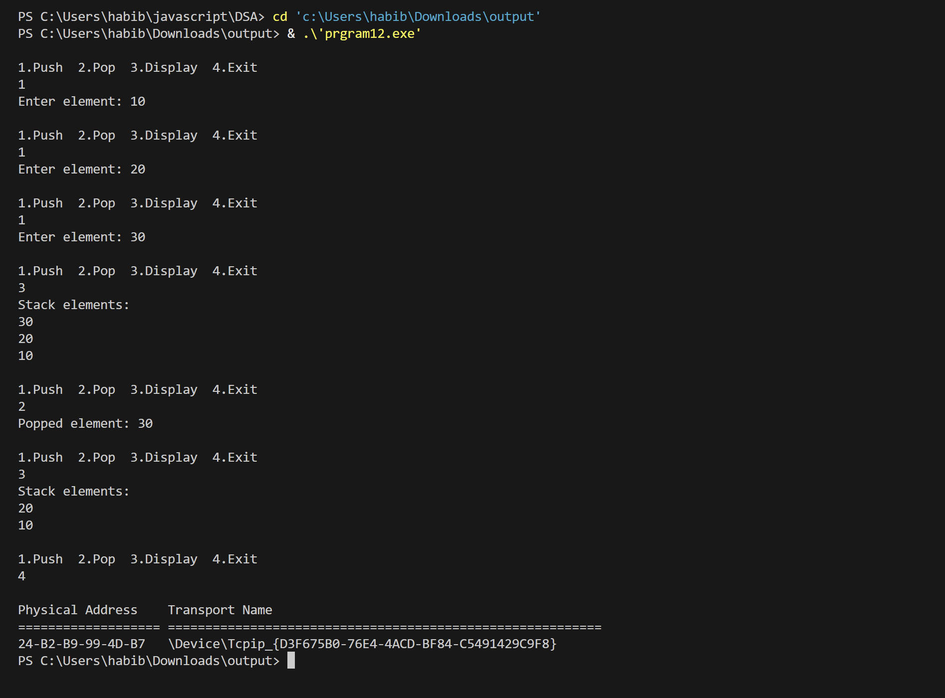

Program:13
#include <stdio.h>
#include <stdlib.h>
struct node {
int data;
struct node *next;
};
struct node *front = NULL;
struct node *rear = NULL;
void enqueue(int x) {
struct node *new = (struct node *)malloc(sizeof(struct node));
new->data = x;
new->next = NULL;
if (rear == NULL) {
front = rear = new;
} else {
rear->next = new;
rear = new;
}
}
void dequeue() {
struct node *temp;
if (front == NULL) {
printf("Queue Underflow\n");
return;
}
temp = front;
printf("Deleted element: %d\n", temp->data);
front = front->next;
if (front == NULL)
rear = NULL;
free(temp);
}
void display() {
struct node *temp = front;
if (front == NULL) {
printf("Queue is empty\n");
return;
}
printf("Queue elements: ");
while (temp != NULL) {
printf("%d ", temp->data);
temp = temp->next;
}
printf("\n");
}
int main() {
int ch, x;
do {
printf("\n1.Enqueue 2.Dequeue 3.Display 4.Exit\n");
scanf("%d", &ch);
switch (ch) {
case 1:
printf("Enter element: ");
scanf("%d", &x);
enqueue(x);
break;
case 2:
dequeue();
break;
case 3:
display();
break;
}
} while (ch != 4);
system("getmac");
return 0;
}

Output:
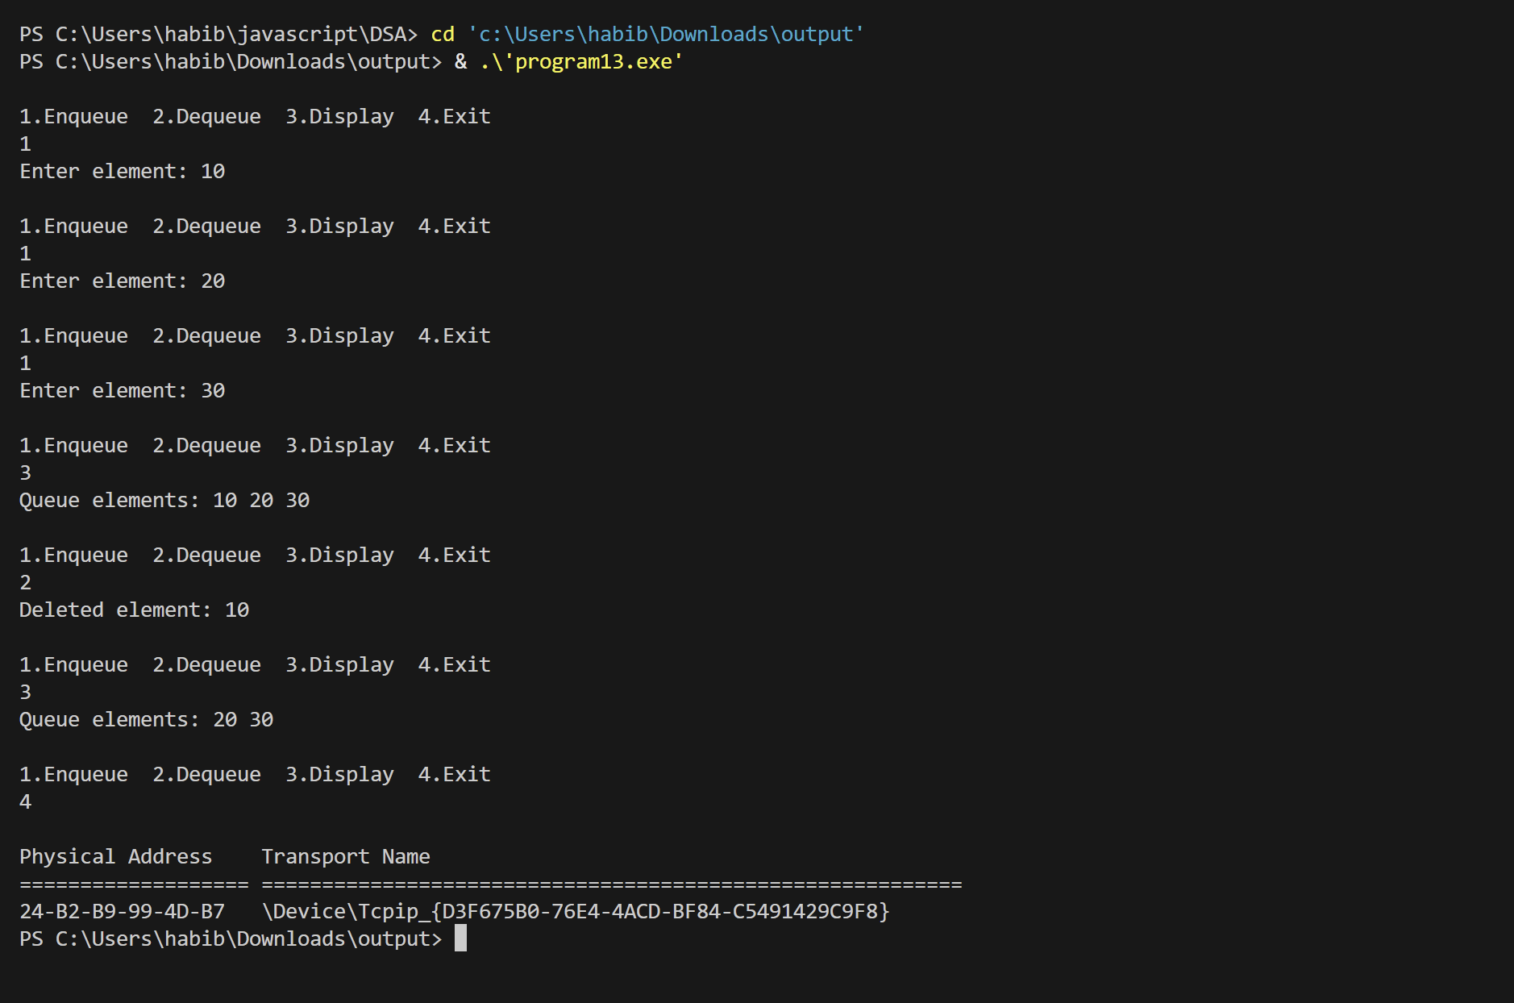

Program:14
#include <stdio.h>
#include <stdlib.h>
#include <time.h>
struct node {
int data;
struct node *next;
};
struct node *head = NULL;
void ll_insert(int x) {
struct node *new = (struct node *)malloc(sizeof(struct node));
new->data = x;
new->next = NULL;
if (head == NULL)
head = new;
else {
struct node *temp = head;
while (temp->next != NULL)
temp = temp->next;
temp->next = new;
}
}
void ll_delete() {
if (head == NULL) return;
if (head->next == NULL) {
free(head);
head = NULL;
return;
}
struct node *temp = head;
while (temp->next->next != NULL)
temp = temp->next;
free(temp->next);
temp->next = NULL;
}
int main() {
int n, i;
printf("Enter number of elements: ");
scanf("%d", &n);
int *arr = (int *)malloc(n * sizeof(int));
clock_t start, end;
start = clock();
for (i = 0; i < n; i++)
arr[i] = i;
end = clock();
printf("Array insertion time: %f seconds\n", (double)(end - start)/CLOCKS_PER_SEC);
start = clock();
for (i = 0; i < n; i++)
ll_insert(i);
end = clock();
printf("Linked list insertion time: %f seconds\n", (double)(end - start)/CLOCKS_PER_SEC);
start = clock();
for (i = n-1; i >= 0; i--)
arr[i] = 0; // just clearing
end = clock();
printf("Array deletion time: %f seconds\n", (double)(end - start)/CLOCKS_PER_SEC);
start = clock();
for (i = 0; i < n; i++)
ll_delete();
end = clock();
printf("Linked list deletion time: %f seconds\n", (double)(end - start)/CLOCKS_PER_SEC);
free(arr);
system("getmac");
return 0;
}
Output:
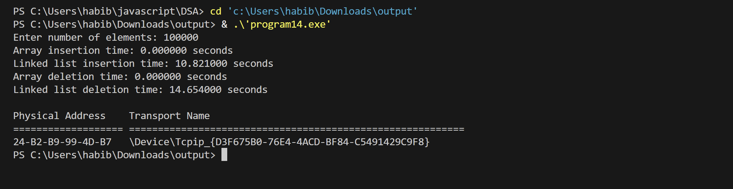

Program:15
#include <stdio.h>
int main() {
int m, n, i, j, k = 0;
printf("Enter number of rows and columns: ");
scanf("%d %d", &m, &n);
int mat[m][n];
printf("Enter elements of the matrix:\n");
for(i = 0; i < m; i++)
for(j = 0; j < n; j++)
scanf("%d", &mat[i][j]);
int count = 0;
for(i = 0; i < m; i++)
for(j = 0; j < n; j++)
if(mat[i][j] != 0)
count++;
int sparse[count][3];
for(i = 0; i < m; i++)
for(j = 0; j < n; j++)
if(mat[i][j] != 0) {
sparse[k][0] = i;
sparse[k][1] = j;
sparse[k][2] = mat[i][j];
k++;
}
printf("\nSparse Matrix Representation (row col value):\n");
for(i = 0; i < count; i++)
printf("%d %d %d\n", sparse[i][0], sparse[i][1], sparse[i][2]);
system("getmac");
return 0;
}

Output:
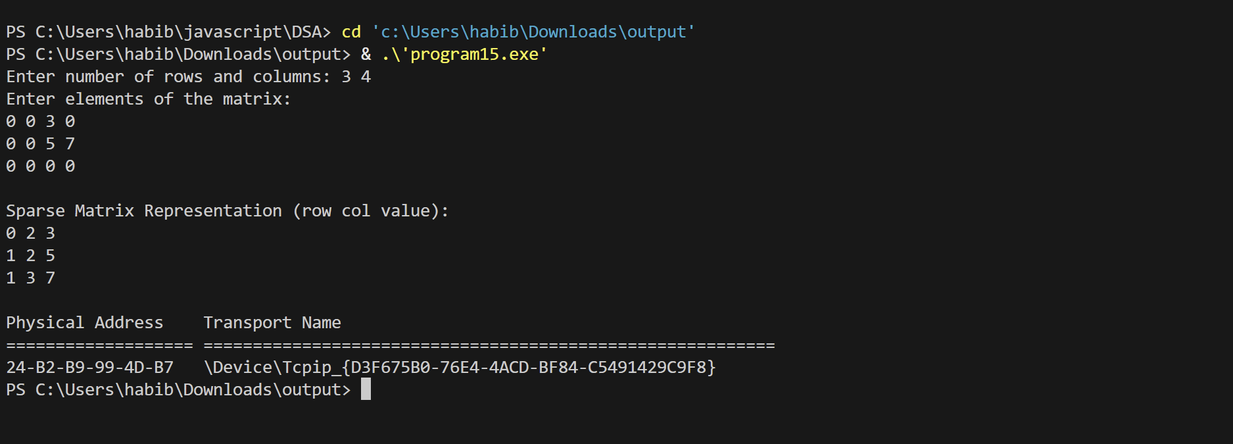

Program:16
#include <stdio.h>
int main() {
int degree, i;
printf("Enter degree of the polynomial: ");
scanf("%d", &degree);
int coeff[degree + 1];
printf("Enter coefficients (from highest degree to constant term):\n");
for(i = degree; i >= 0; i--) {
printf("Coefficient of x^%d: ", i);
scanf("%d", &coeff[i]);
}
printf("Polynomial: ");
for(i = degree; i >= 0; i--) {
if(coeff[i] != 0) {
if(i != degree && coeff[i] > 0) printf("+");
printf("%dx^%d ", coeff[i], i);
}
}
printf("\n");
int x;
printf("Enter value of x to evaluate: ");
scanf("%d", &x);
int result = 0;
for(i = 0; i <= degree; i++)
result += coeff[i] * pow(x, i);
printf("Polynomial evaluated at x = %d: %d\n", x, result);
system("getmac");
return 0;
}
Output:
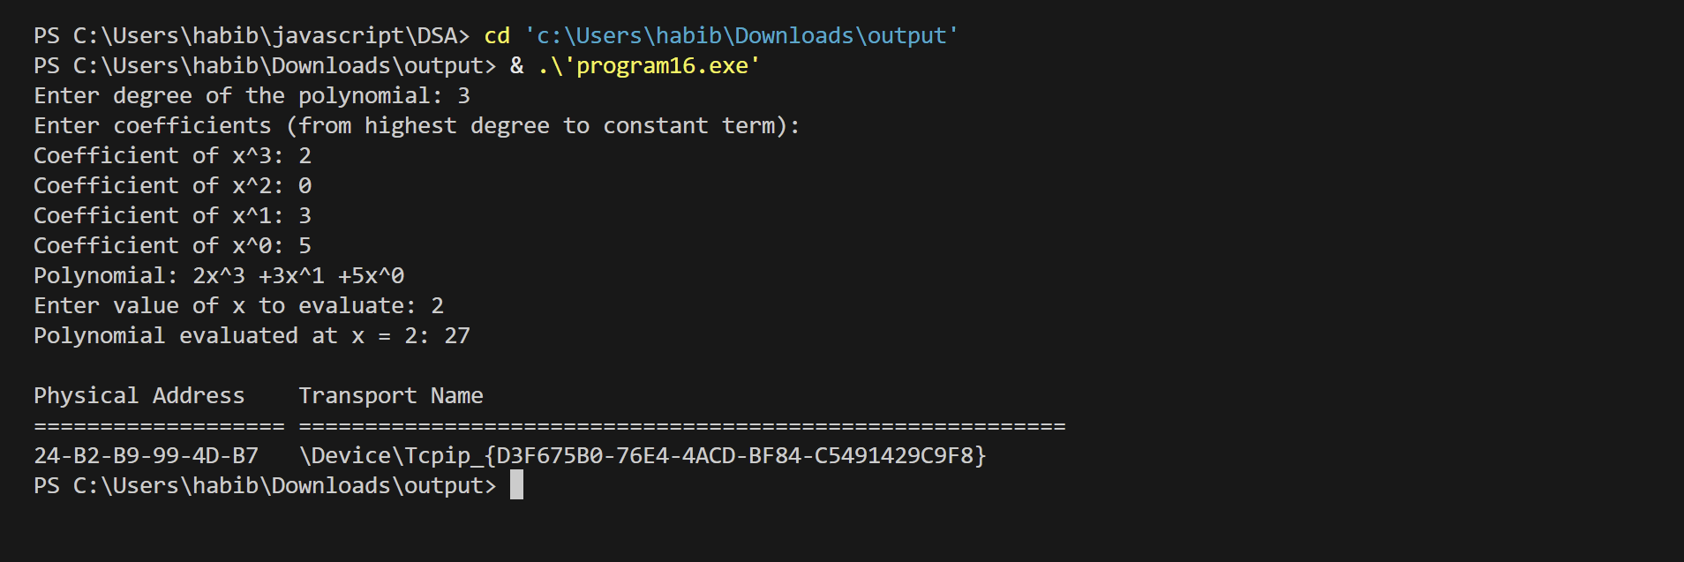

Program:17
#include <stdio.h>
#include <stdlib.h>
struct node {
int data;
struct node *left;
struct node *right;
};
struct node* createNode(int x) {
struct node* newNode = (struct node*)malloc(sizeof(struct node));
newNode->data = x;
newNode->left = newNode->right = NULL;
return newNode;
}
void inorder(struct node* root) {
if (root != NULL) {
inorder(root->left);
printf("%d ", root->data);
inorder(root->right);
}
}
struct node* insert(struct node* root, int x) {
if (root == NULL) return createNode(x);
if (!root->left)
root->left = insert(root->left, x);
else if (!root->right)
root->right = insert(root->right, x);
else
root->left = insert(root->left, x); // simple insertion strategy
return root;
}
int main() {
struct node* root = NULL;
int n, i, x;
printf("Enter number of nodes: ");
scanf("%d", &n);
for(i = 0; i < n; i++) {
printf("Enter node %d value: ", i+1);
scanf("%d", &x);
root = insert(root, x);
}
printf("Inorder traversal of the tree: ");
inorder(root);
printf("\n");
system("getmac");
return 0;
}
Output:
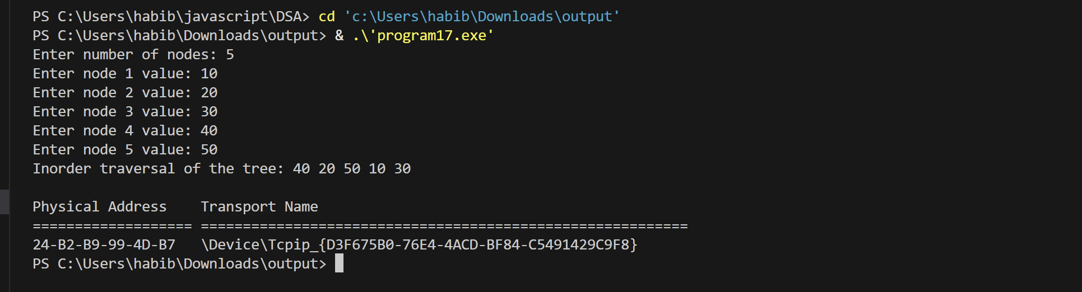

Program:18
#include <stdio.h>
void inorder(int tree[], int n, int index) {
if (index >= n || tree[index] == -1) return; // -1 indicates empty node
inorder(tree, n, 2*index + 1); // left child
printf("%d ", tree[index]);
inorder(tree, n, 2*index + 2); // right child
}
int main() {
int n, i;
printf("Enter number of nodes: ");
scanf("%d", &n);
int tree[n];
printf("Enter node values (-1 for NULL node):\n");
for(i = 0; i < n; i++)
scanf("%d", &tree[i]);
printf("Inorder traversal of the tree: ");
inorder(tree, n, 0);
printf("\n");
system("getmac");
return 0;
}
Output:
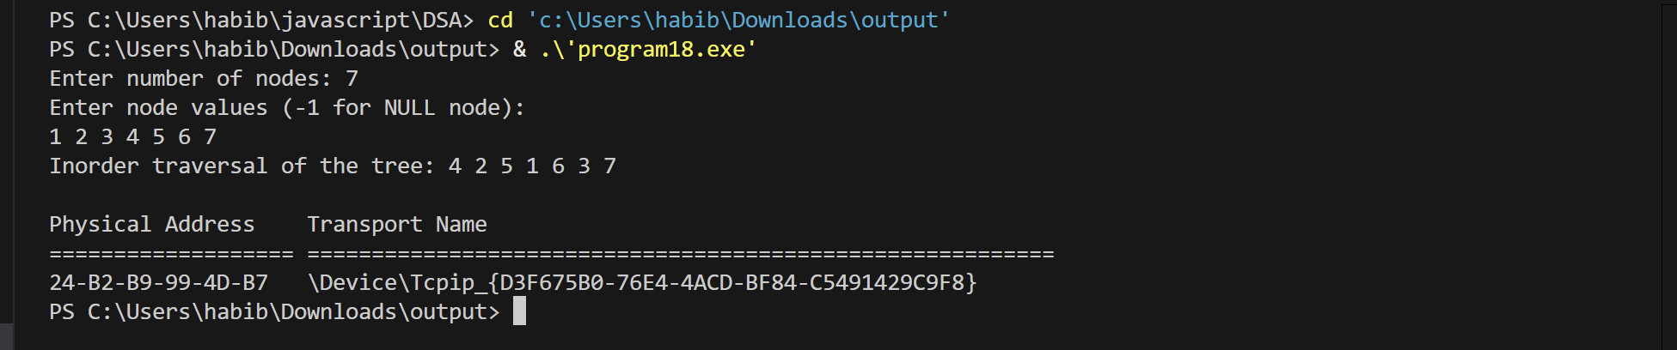

Program:19
#include <stdio.h>
#include <stdlib.h>
struct node {
int data;
struct node *left;
struct node *right;
};
struct queueNode {
struct node *treeNode;
struct queueNode *next;
};
struct queueNode *front = NULL, *rear = NULL;
void enqueue(struct node *t) {
struct queueNode *newQ = (struct queueNode*)malloc(sizeof(struct queueNode));
newQ->treeNode = t;
newQ->next = NULL;
if(rear == NULL) {
front = rear = newQ;
} else {
rear->next = newQ;
rear = newQ;
}
}
struct node* dequeue() {
if(front == NULL) return NULL;
struct queueNode *temp = front;
struct node *t = temp->treeNode;
front = front->next;
if(front == NULL) rear = NULL;
free(temp);
return t;
}
int isEmpty() {
return front == NULL;
}
struct node* createNode(int x) {
struct node* newNode = (struct node*)malloc(sizeof(struct node));
newNode->data = x;
newNode->left = newNode->right = NULL;
return newNode;
}
void inorder(struct node *root) {
if(root != NULL) {
inorder(root->left);
printf("%d ", root->data);
inorder(root->right);
}
}
int main() {
int x;
struct node *root = NULL;
struct node *temp;
printf("Enter root value: ");
scanf("%d", &x);
root = createNode(x);
enqueue(root);
while(!isEmpty()) {
temp = dequeue();
printf("Enter left child of %d (-1 for NULL): ", temp->data);
scanf("%d", &x);
if(x != -1) {
temp->left = createNode(x);
enqueue(temp->left);
}
printf("Enter right child of %d (-1 for NULL): ", temp->data);
scanf("%d", &x);
if(x != -1) {
temp->right = createNode(x);
enqueue(temp->right);
}
}
printf("Inorder traversal of the tree: ");
inorder(root);
printf("\n");
system("getmac");
return 0;
}

Output:
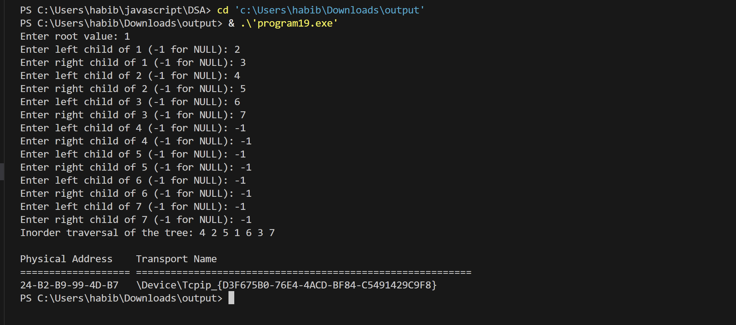

Program:20
#include <stdio.h>
#include <stdlib.h>
struct node {
int data;
struct node *next;
};
struct node *head = NULL;
void insert(int x) {
struct node *newNode = (struct node *)malloc(sizeof(struct node));
newNode->data = x;
newNode->next = NULL;
if (head == NULL) {
head = newNode;
} else {
struct node *temp = head;
while (temp->next != NULL)
temp = temp->next;
temp->next = newNode;
}
}
void display() {
struct node *temp = head;
if (head == NULL) {
printf("List is empty\n");
return;
}
printf("Linked List: ");
while (temp != NULL) {
printf("%d -> ", temp->data);
temp = temp->next;
}
printf("NULL\n");
}
int main() {
int n, x, i;
printf("Enter number of nodes to insert: ");
scanf("%d", &n);
for (i = 0; i < n; i++) {
printf("Enter value for node %d: ", i+1);
scanf("%d", &x);
insert(x);
}
display();
system("getmac");
return 0;
}

Output:
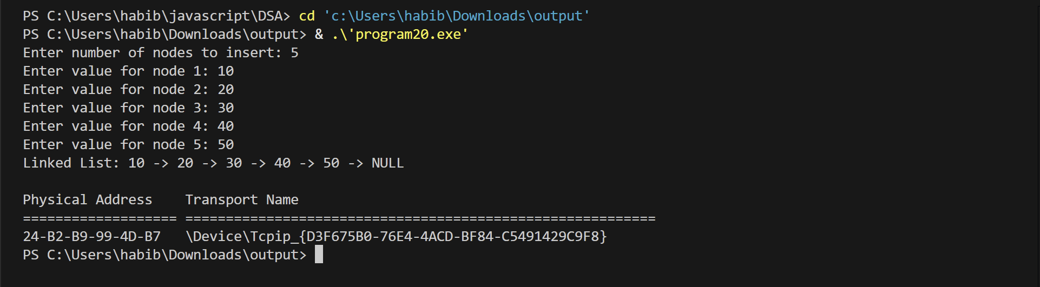

Program:21
#include <stdio.h>
#include <stdlib.h>
struct node {
int data;
struct node *next;
};
struct node *head = NULL;
void insert(int x) {
struct node *newNode = (struct node *)malloc(sizeof(struct node));
newNode->data = x;
newNode->next = NULL;
if (head == NULL) {
head = newNode;
}
else {
struct node *temp = head;
while (temp->next != NULL)
temp = temp->next;
temp->next = newNode;
}
}
void deleteNode(int x) {
struct node *temp = head, *prev = NULL;
if (head == NULL) {
printf("List is empty\n");
return;
}
if (head->data == x) {
head = head->next;
free(temp);
return;
}
while (temp != NULL && temp->data != x) {
prev = temp;
temp = temp->next;
}
if (temp == NULL) {
printf("Element %d not found\n", x);
return;
}
prev->next = temp->next;
free(temp);
}
void display() {
struct node *temp = head;
if (head == NULL) {
printf("List is empty\n");
return;
}
printf("Linked List: ");
while (temp != NULL) {
printf("%d -> ", temp->data);
temp = temp->next;
}
printf("NULL\n");
}
int main() {
int n, x, i;
printf("Enter number of nodes to insert: ");
scanf("%d", &n);
for (i = 0; i < n; i++) {
printf("Enter value for node %d: ", i+1);
scanf("%d", &x);
insert(x);
}
display();
printf("Enter value to delete: ");
scanf("%d", &x);
deleteNode(x);
display();
system("getmac");
return 0;
}
Output:
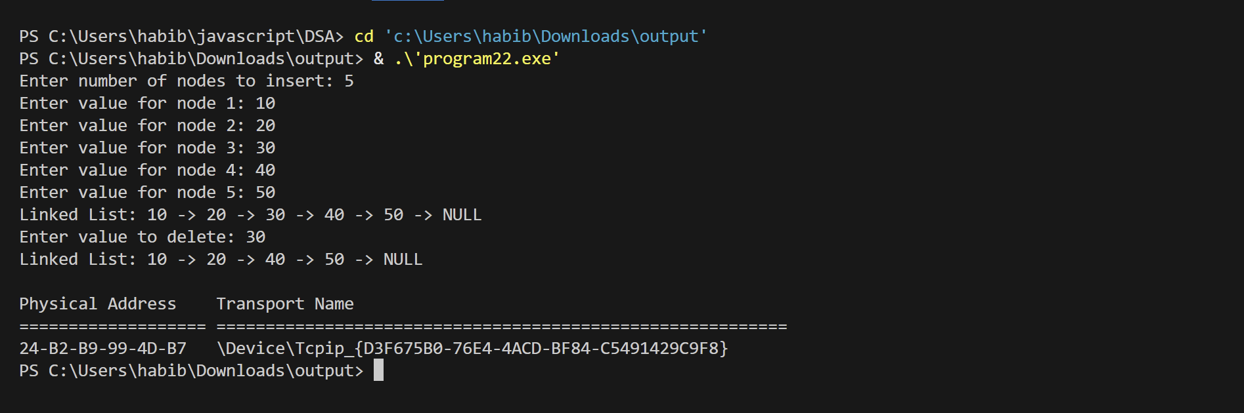

Program:22
#include <stdio.h>
#include <stdlib.h>
struct node {
int data;
struct node *left;
struct node *right;
};
struct node* createNode(int x) {
struct node* newNode = (struct node*)malloc(sizeof(struct node));
newNode->data = x;
newNode->left = newNode->right = NULL;
return newNode;
}
void DFS(struct node* root) {
if(root == NULL) return;
printf("%d ", root->data); // Visit root
DFS(root->left); // Visit left subtree
DFS(root->right); // Visit right subtree
}
struct node* insertLevelOrder(int arr[], int i, int n) {
if(i >= n || arr[i] == -1) return NULL;
struct node* root = createNode(arr[i]);
root->left = insertLevelOrder(arr, 2*i + 1, n);
root->right = insertLevelOrder(arr, 2*i + 2, n);
return root;
}
int main() {
int n, i;
printf("Enter number of nodes: ");
scanf("%d", &n);
int arr[n];
printf("Enter node values (-1 for NULL node):\n");
for(i = 0; i < n; i++)
scanf("%d", &arr[i]);
struct node* root = insertLevelOrder(arr, 0, n);
printf("DFS (Preorder) traversal of the tree: ");
DFS(root);
printf("\n");
system("getmac");
return 0;
}
Output:
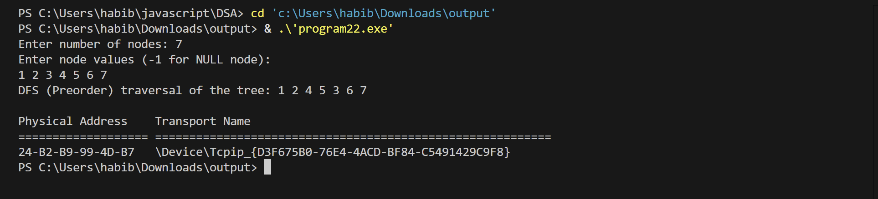

Program:23
#include <stdio.h>
#include <stdlib.h>
struct node {
int data;
struct node *left;
struct node *right;
};
struct queueNode {
struct node *treeNode;
struct queueNode *next;
};
struct queueNode *front = NULL, *rear = NULL;
void enqueue(struct node *t) {
struct queueNode *newQ = (struct queueNode*)malloc(sizeof(struct queueNode));
newQ->treeNode = t;
newQ->next = NULL;
if(rear == NULL) {
front = rear = newQ;
} else {
rear->next = newQ;
rear = newQ;
}
}
struct node* dequeue() {
if(front == NULL) return NULL;
struct queueNode *temp = front;
struct node *t = temp->treeNode;
front = front->next;
if(front == NULL) rear = NULL;
free(temp);
return t;
}
int isEmpty() {
return front == NULL;
}
struct node* createNode(int x) {
struct node* newNode = (struct node*)malloc(sizeof(struct node));
newNode->data = x;
newNode->left = newNode->right = NULL;
return newNode;
}
void BFS(struct node *root) {
if(root == NULL) return;
enqueue(root);
while(!isEmpty()) {
struct node *temp = dequeue();
printf("%d ", temp->data);
if(temp->left != NULL) enqueue(temp->left);
if(temp->right != NULL) enqueue(temp->right);
}
}
int main() {
int n, i;
printf("Enter number of nodes: ");
scanf("%d", &n);
int arr[n];
printf("Enter node values (-1 for NULL node):\n");
for(i = 0; i < n; i++)
scanf("%d", &arr[i]);
struct node *root = NULL;
struct node *nodes[n];
for(i = 0; i < n; i++) {
if(arr[i] == -1) {
nodes[i] = NULL;
continue;
}
nodes[i] = createNode(arr[i]);
if(i == 0) root = nodes[i];
int parent = (i - 1) / 2;
if(nodes[parent] != NULL) {
if(i % 2 == 1) nodes[parent]->left = nodes[i];
else nodes[parent]->right = nodes[i];
}
}
printf("BFS (Level-Order) traversal of the tree: ");
BFS(root);
printf("\n");
system("getmac");
return 0;
}
Output:
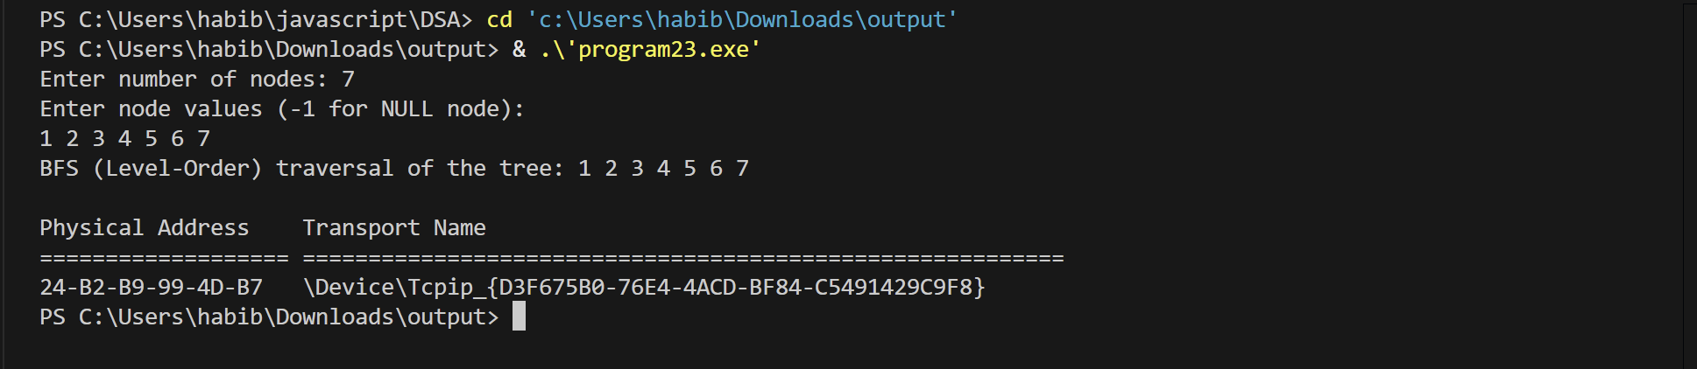

Program:24
#include <stdio.h>
#include <stdlib.h>
struct node {
int data;
struct node *left;
struct node *right;
};
struct queueNode {
struct node *treeNode;
struct queueNode *next;
};
struct queueNode *front = NULL, *rear = NULL;
void enqueue(struct node *t) {
struct queueNode *newQ = (struct queueNode*)malloc(sizeof(struct queueNode));
newQ->treeNode = t;
newQ->next = NULL;
if(rear == NULL) {
front = rear = newQ;
} else {
rear->next = newQ;
rear = newQ;
}
}
struct node* dequeue() {
if(front == NULL) return NULL;
struct queueNode *temp = front;
struct node *t = temp->treeNode;
front = front->next;
if(front == NULL) rear = NULL;
free(temp);
return t;
}
int is Empty() {
return front == NULL;
}
struct node* createNode(int x) {
struct node* newNode = (struct node*)malloc(sizeof(struct node));
newNode->data = x;
newNode->left = newNode->right = NULL;
return newNode;
}
void levelOrder(struct node *root) {
if(root == NULL) return;
enqueue(root);
while(!isEmpty()) {
struct node *temp = dequeue();
printf("%d ", temp->data);
if(temp->left != NULL) enqueue(temp->left);
if(temp->right != NULL) enqueue(temp->right);
}
}
int main() {
int n, i;
printf("Enter number of nodes: ");
scanf("%d", &n);
int arr[n];
printf("Enter node values (-1 for NULL node):\n");
for(i = 0; i < n; i++)
scanf("%d", &arr[i]);
struct node *nodes[n];
struct node *root = NULL;
for(i = 0; i < n; i++) {
if(arr[i] == -1) {
nodes[i] = NULL;
continue;
}
nodes[i] = createNode(arr[i]);
if(i == 0) root = nodes[i];
int parent = (i - 1) / 2;
if(nodes[parent] != NULL) {
if(i % 2 == 1) nodes[parent]->left = nodes[i];
else nodes[parent]->right = nodes[i];
}
}
printf("Level-order traversal of the tree: ");
levelOrder(root);
printf("\n");
system("getmac");
return 0;
}
Output:
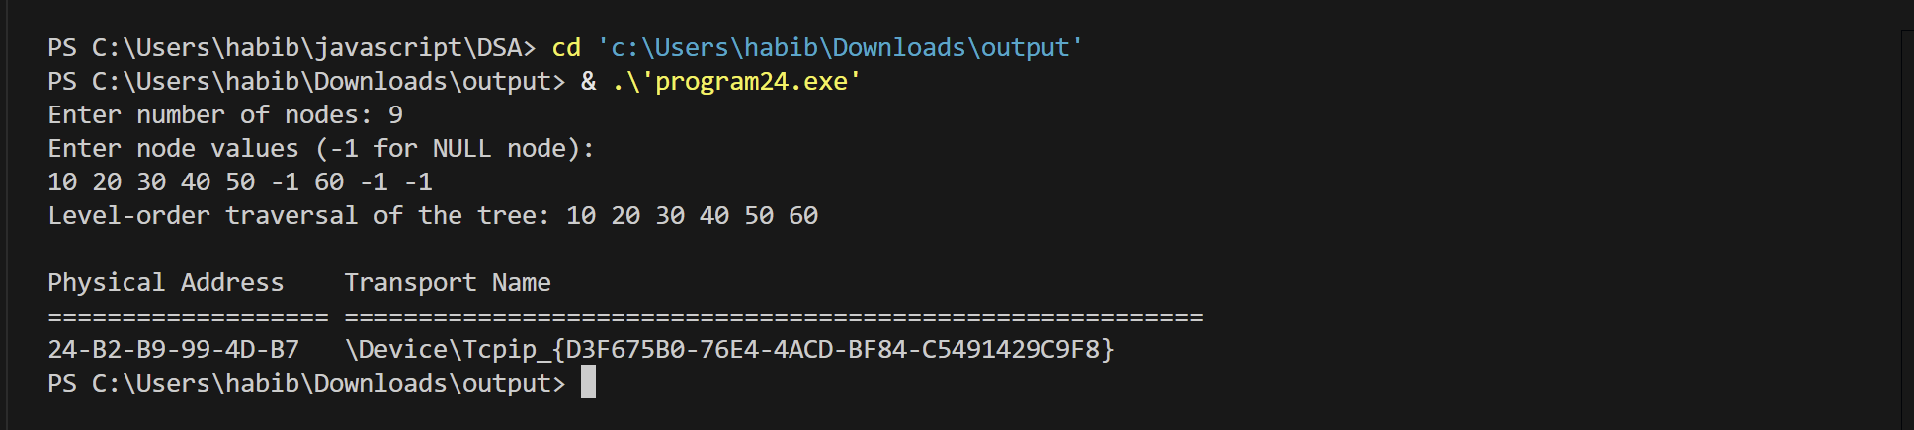

Program:25
#include <stdio.h>
#include <stdlib.h>
struct adjNode {
int dest;
struct adjNode* next;
};
struct Graph {
int V;
struct adjNode** array;
};
struct adjNode* newAdjNode(int dest) {
struct adjNode* newNode = (struct adjNode*)malloc(sizeof(struct adjNode));
newNode->dest = dest;
newNode->next = NULL;
return newNode;
}
struct Graph* createGraph(int V) {
struct Graph* graph = (struct Graph*)malloc(sizeof(struct Graph));
graph->V = V;
graph->array = (struct adjNode**)malloc(V * sizeof(struct adjNode*));
for(int i=0;i<V;i++) graph->array[i] = NULL;
return graph;
}
void addEdge(struct Graph* graph, int src, int dest) {
struct adjNode* newNode = newAdjNode(dest);
newNode->next = graph->array[src];
graph->array[src] = newNode;
newNode = newAdjNode(src);
newNode->next = graph->array[dest];
graph->array[dest] = newNode;
}
struct Stack {
int items[100];
int top;
};
void push(struct Stack* s, int val) { s->items[++(s->top)] = val; }
int pop(struct Stack* s) { return s->items[(s->top)--]; }
int isEmptyStack(struct Stack* s) { return s->top == -1; }
struct Queue {
int items[100];
int front, rear;
};
void enqueue(struct Queue* q, int val) { q->items[++(q->rear)] = val; }
int dequeue(struct Queue* q) { return q->items[(q->front)++]; }
int isEmptyQueue(struct Queue* q) { return q->front > q->rear; }
void DFS(struct Graph* graph, int start) {
int V = graph->V;
int visited[V];
for(int i=0;i<V;i++) visited[i]=0;
struct Stack s;
s.top = -1;
push(&s, start);
printf("DFS Traversal: ");
while(!isEmptyStack(&s)) {
int v = pop(&s);
if(!visited[v]) {
printf("%d ", v);
visited[v] = 1;
}
struct adjNode* temp = graph->array[v];
while(temp) {
if(!visited[temp->dest]) push(&s, temp->dest);
temp = temp->next;
}
}
printf("\n");
}
void BFS(struct Graph* graph, int start) {
int V = graph->V;
int visited[V];
for(int i=0;i<V;i++) visited[i]=0;
struct Queue q;
q.front=0; q.rear=-1;
enqueue(&q, start);
visited[start] = 1;
printf("BFS Traversal: ");
while(!isEmptyQueue(&q)) {
int v = dequeue(&q);
printf("%d ", v);
struct adjNode* temp = graph->array[v];
while(temp) {
if(!visited[temp->dest]) {
enqueue(&q, temp->dest);
visited[temp->dest] = 1;
}
temp = temp->next;
}
}
printf("\n");
}
int main() {
int V, E, u, v;
printf("Enter number of vertices: ");
scanf("%d", &V);
printf("Enter number of edges: ");
scanf("%d", &E);
struct Graph* graph = createGraph(V);
printf("Enter edges (src dest):\n");
for(int i=0;i<E;i++) {
scanf("%d %d", &u, &v);
addEdge(graph, u, v);
}
DFS(graph, 0); // DFS starting from vertex 0
BFS(graph, 0); // BFS starting from vertex 0
system("getmac");
return 0;
}

Output:
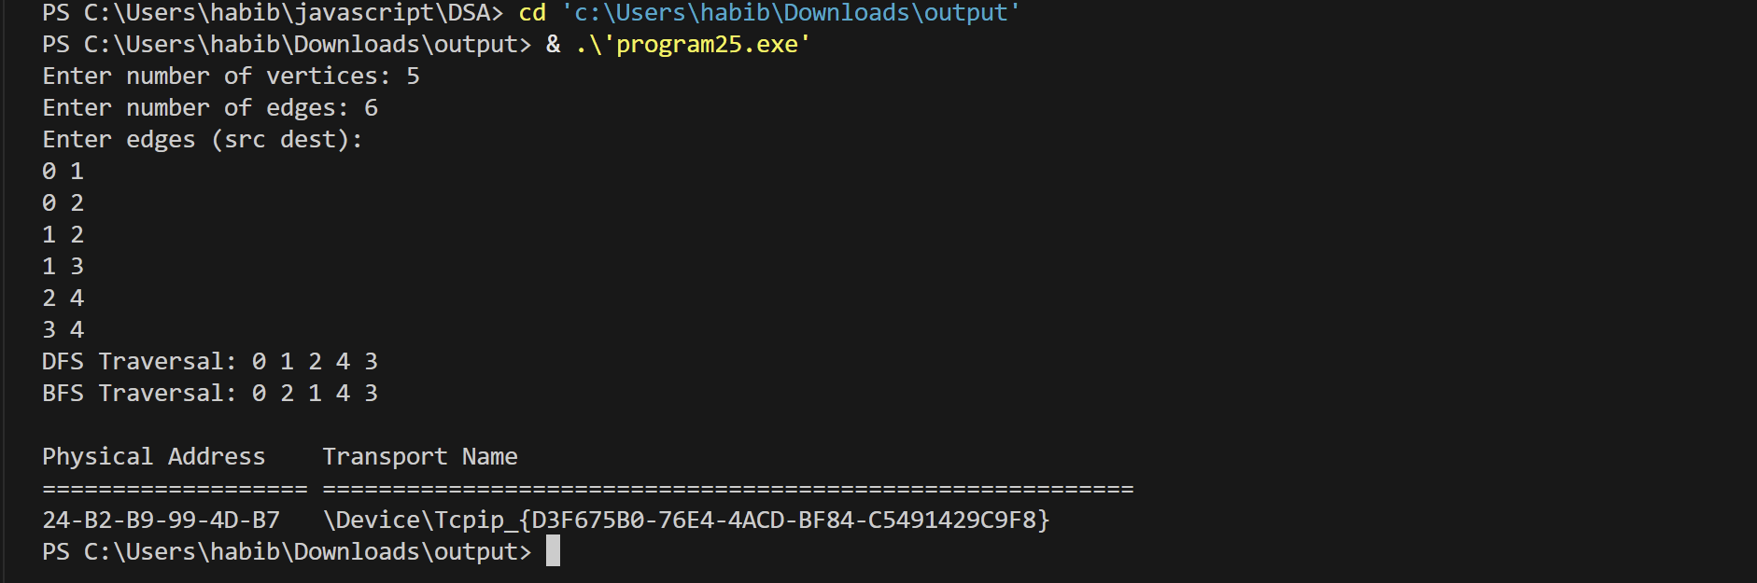

Program:26
#include <stdio.h>
#include <stdlib.h>
int main() {
int n = 5;
int *m, *c, i;
m = (int *)malloc(n * sizeof(int));
c = (int *)calloc(n, sizeof(int));
printf("Values after malloc():\n");
for(i = 0; i < n; i++)
printf("%d ", m[i]);
printf("\n\nValues after calloc():\n");
for(i = 0; i < n; i++)
printf("%d ", c[i]);
free(m);
free(c);
system("getmac");
return 0;
}

Output:
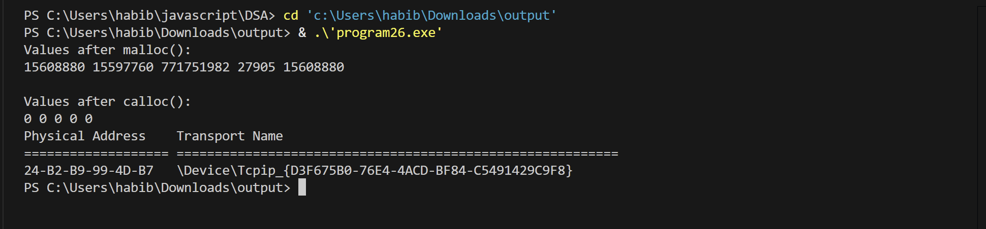

Program:27
#include <stdio.h>
#include <stdlib.h>
struct node {
int data;
struct node *next;
};
struct node *last = NULL;
void insert(int val) {
struct node *newNode = (struct node*)malloc(sizeof(struct node));
newNode->data = val;
if (last == NULL) {
last = newNode;
newNode->next = newNode; // circular link
} else {
newNode->next = last->next;
last->next = newNode;
last = newNode;
}
}
void delete(int val) {
if (last == NULL) {
printf("List is empty\n");
return;
}
struct node *curr = last->next, *prev = last;
do {
if (curr->data == val) {
if (curr == last && curr->next == last) {
last = NULL;
} else {
prev->next = curr->next;
if (curr == last)
last = prev;
}
free(curr);
printf("Deleted %d\n", val);
return;
}
prev = curr;
curr = curr->next;
} while (curr != last->next);
printf("Element not found\n");
}
void display() {
if (last == NULL) {
printf("List is empty\n");
return;
}
struct node *temp = last->next;
printf("Circular Linked List: ");
do {
printf("%d ", temp->data);
temp = temp->next;
} while (temp != last->next);
printf("\n");
}
int main() {
int ch, val;
do {
printf("\n1.Insert\n2.Delete\n3.Display\n4.Exit\n");
printf("Enter choice: ");
scanf("%d", &ch);
switch(ch) {
case 1:
printf("Enter value to insert: ");
scanf("%d", &val);
insert(val);
break;
case 2:
printf("Enter value to delete: ");
scanf("%d", &val);
delete(val);
break;
case 3:
display();
break;
case 4:
printf("Exit\n");
break;
default:
printf("Invalid choice\n");
}
} while (ch != 4);
system("getmac");
return 0;
}
Output:
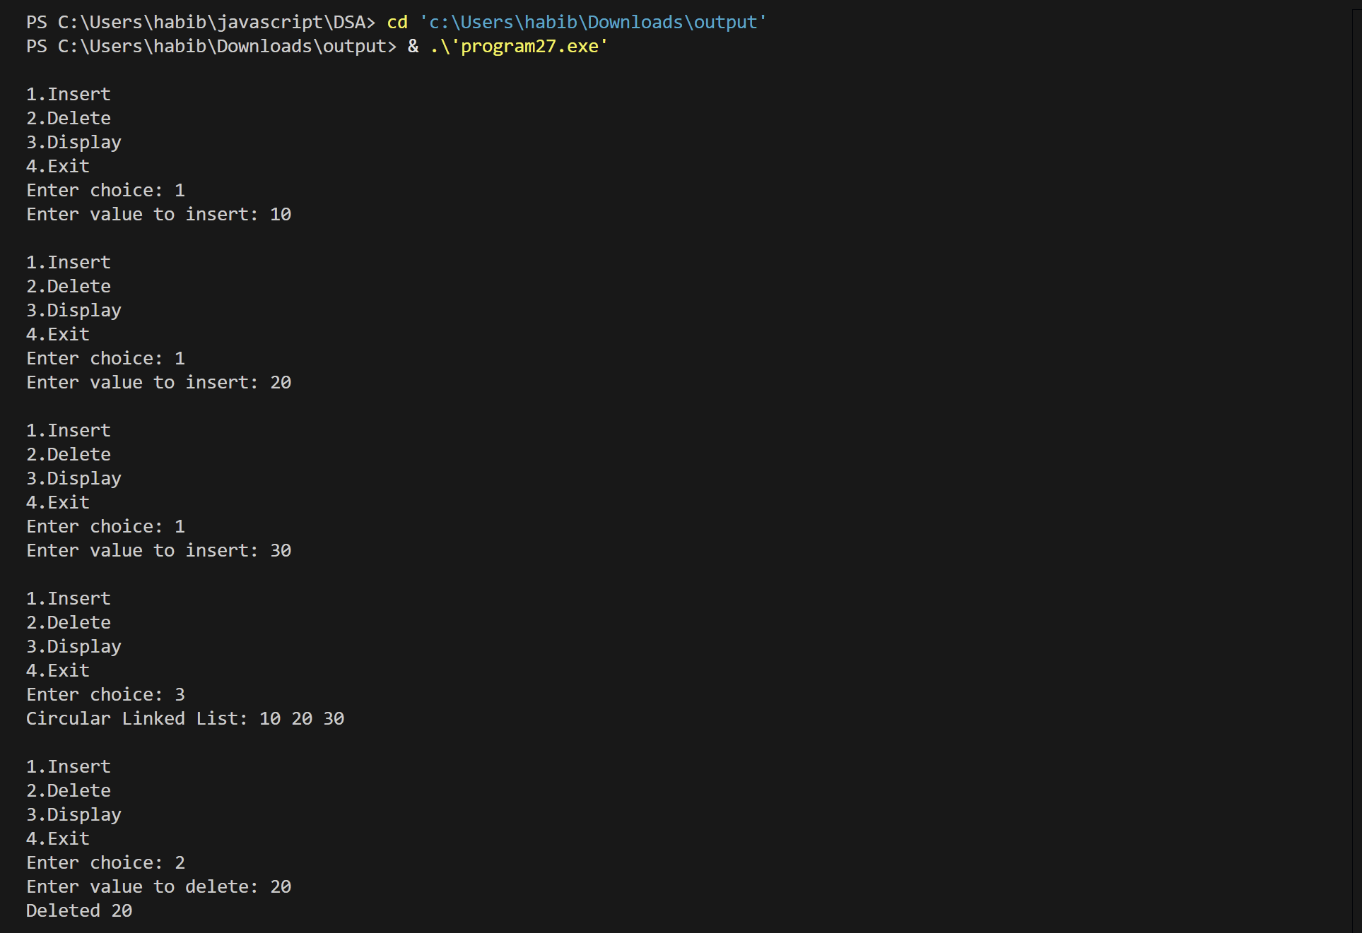
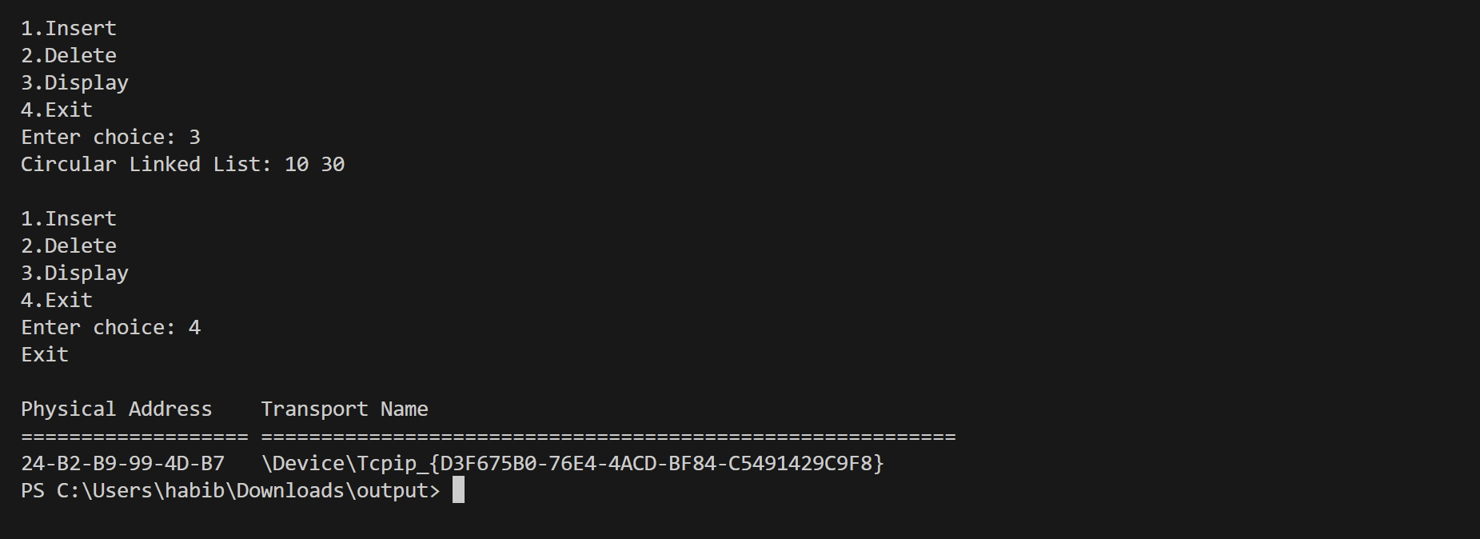

Program:28
#include <stdio.h>
#include <string.h>
int main() {
char str1[50], str2[50];
printf("Enter first string: ");
scanf("%s", str1);
printf("Enter second string: ");
scanf("%s", str2);
if (strcmp(str1, str2) == 0)
printf("Strings are equal\n");
else
printf("Strings are not equal\n");
system("getmac");
return 0;
}
Output:
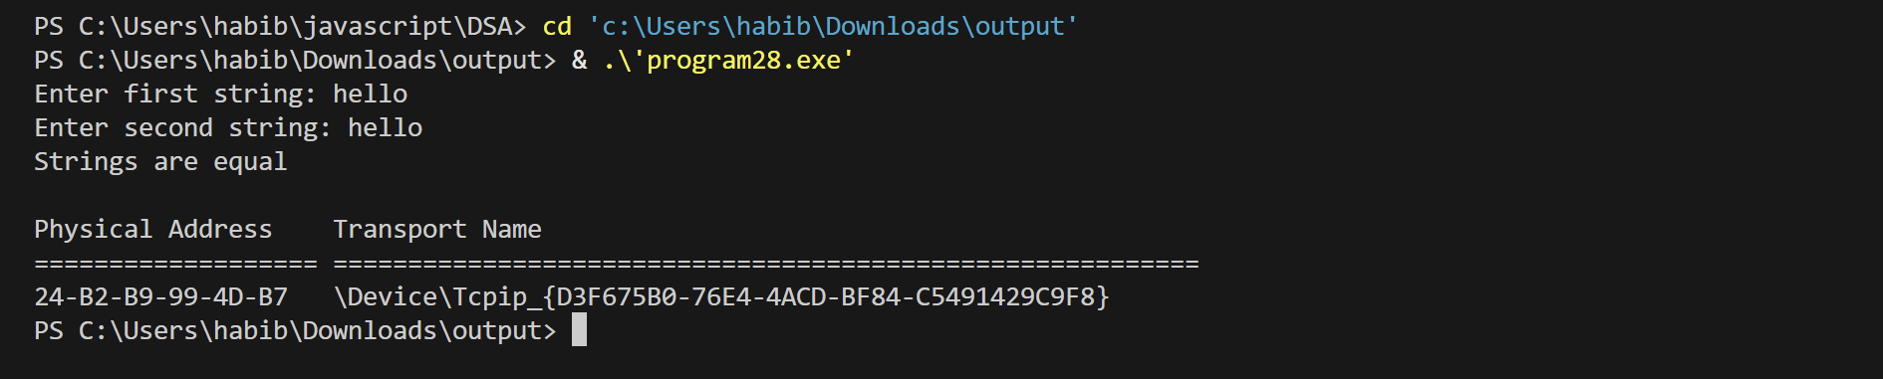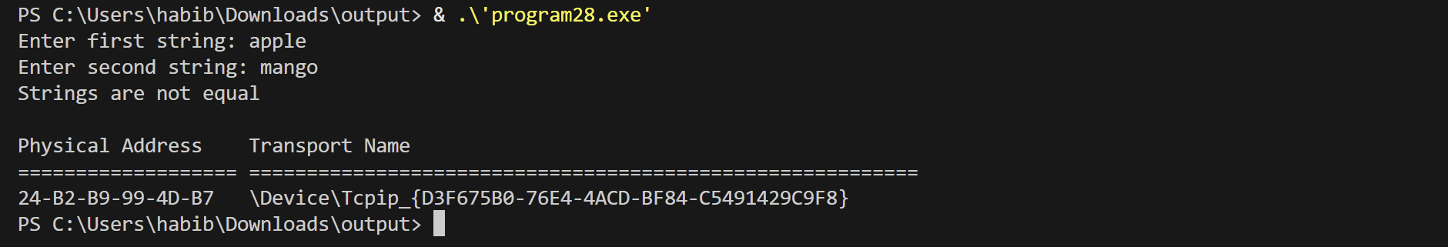

Program:29
#include <stdio.h>
#include <stdlib.h>
struct node {
int data;
struct node *next;
};
struct node* insertEnd(struct node* head, int val) {
struct node* newNode = (struct node*)malloc(sizeof(struct node));
newNode->data = val;
newNode->next = NULL;
if (head == NULL)
return newNode;
struct node* temp = head;
while (temp->next != NULL)
temp = temp->next;
temp->next = newNode;
return head;
}
struct node* insertMiddle(struct node* head, int val, int pos) {
struct node* newNode = (struct node*)malloc(sizeof(struct node));
newNode->data = val;
struct node* temp = head;
for (int i = 1; i < pos && temp != NULL; i++)
temp = temp->next;
if (temp == NULL) {
printf("Position not valid\n");
return head;
}
newNode->next = temp->next;
temp->next = newNode;
return head;
}

struct node* deleteMiddle(struct node* head) {
if (head == NULL || head->next == NULL) {
printf("Cannot delete middle\n");
return NULL;
}
struct node *slow = head, *fast = head;
struct node *prev = NULL;
while (fast != NULL && fast->next != NULL) {
fast = fast->next->next;
prev = slow;
slow = slow->next;
}
prev->next = slow->next;
free(slow);
return head;
}
void display(struct node* head) {
struct node* temp = head;
while (temp != NULL) {
printf("%d ", temp->data);
temp = temp->next;
}
printf("\n");
}
int main() {
struct node* head = NULL;
int n, val, pos;
printf("Enter number of nodes: ");
scanf("%d", &n);
printf("Enter values:\n");
for (int i = 0; i < n; i++) {
scanf("%d", &val);
head = insertEnd(head, val);
}
printf("Original List: ");
display(head);
printf("Enter value to insert in middle: ");
scanf("%d", &val);
printf("Enter position(after which to insert): ");
scanf("%d", &pos);
head = insertMiddle(head, val, pos);
printf("After Insertion: ");
display(head);
head = deleteMiddle(head);
printf("After Deletion of Middle: ");
display(head);
system("getmac");
return 0;
}
Output:
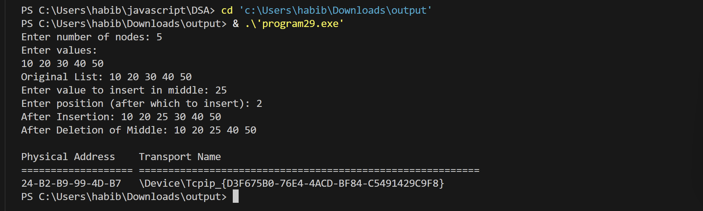

Program:30
#include <stdio.h>
#include <stdlib.h>
struct node {
int data;
struct node *left, *right;
};
struct node* createNode(int val) {
struct node* n = (struct node*)malloc(sizeof(struct node));
n->data = val;
n->left = n->right = NULL;
return n;
}
void inorder(struct node* root) {
if (root != NULL) {
inorder(root->left);
printf("%d ", root->data);
inorder(root->right);
}
}
void preorder(struct node* root) {
if (root != NULL) {
printf("%d ", root->data);
preorder(root->left);
preorder(root->right);
}
}
void postorder(struct node* root) {
if (root != NULL) {
postorder(root->left);
postorder(root->right);
printf("%d ", root->data);
}
}
int main() {
struct node* root = createNode(1);
root->left = createNode(2);
root->right = createNode(3);
root->left->left = createNode(4);
root->left->right = createNode(5);
printf("Inorder Traversal: ");
inorder(root);
printf("\nPreorder Traversal: ");
preorder(root);
printf("\nPostorder Traversal: ");
postorder(root);
system("getmac");
return 0;
}
Output:
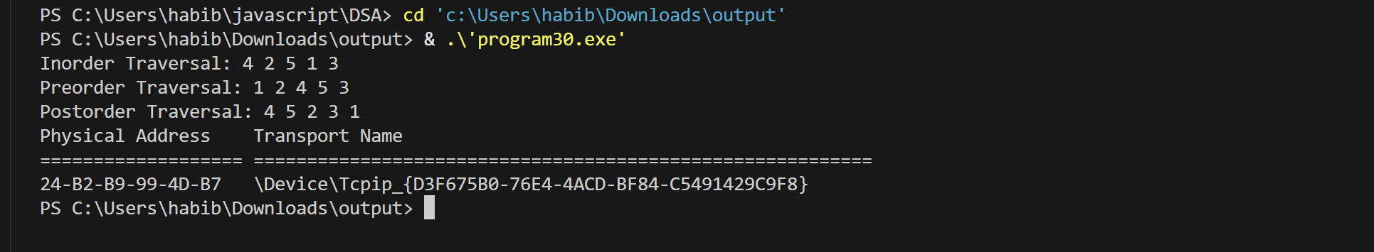

Program:31
#include <stdio.h>
#define SIZE 5
int queue[SIZE];
int front = -1, rear = -1;
void enqueue(int x) {
if ((rear + 1) % SIZE == front) {
printf("Queue is FULL\n");
return;
}
if (front == -1)
front = 0;
rear = (rear + 1) % SIZE;
queue[rear] = x;
printf("Inserted %d\n", x);
}
void dequeue() {
if (front == -1) {
printf("Queue is EMPTY\n");
return;
}
printf("Deleted %d\n", queue[front]);
if (front == rear)
front = rear = -1;
else
front = (front + 1) % SIZE;
}
void display() {
int i;
if (front == -1) {
printf("Queue is EMPTY\n");
return;
}
printf("Queue elements: ");
i = front;
while (1) {
printf("%d ", queue[i]);
if (i == rear)
break;
i = (i + 1) % SIZE;
}
printf("\n");
}
int main() {
int ch, val;
while (1) {
printf("\n1.Enqueue\n2.Dequeue\n3.Display\n4.Exit\n");
printf("Enter choice: ");
scanf("%d", &ch);
switch (ch) {
case 1:
printf("Enter value: ");
scanf("%d", &val);
enqueue(val);
break;
case 2:
dequeue();
break;
case 3:
display();
break;
case 4:
system("getmac");
return 0;
default:
printf("Invalid choice\n");
}
}
}

Output:
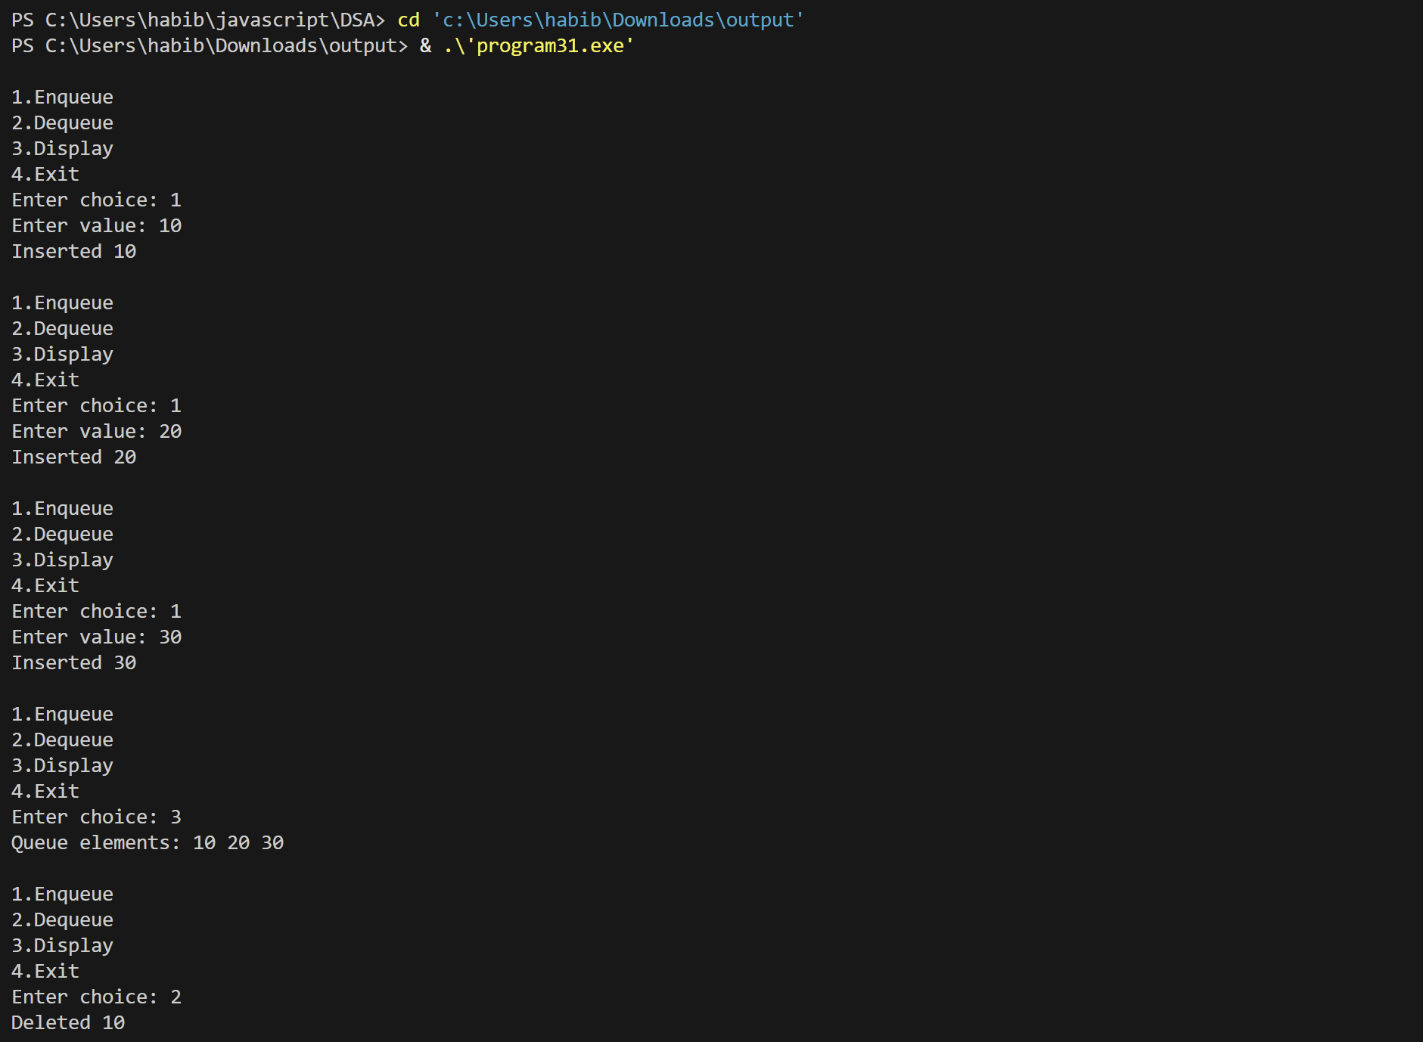
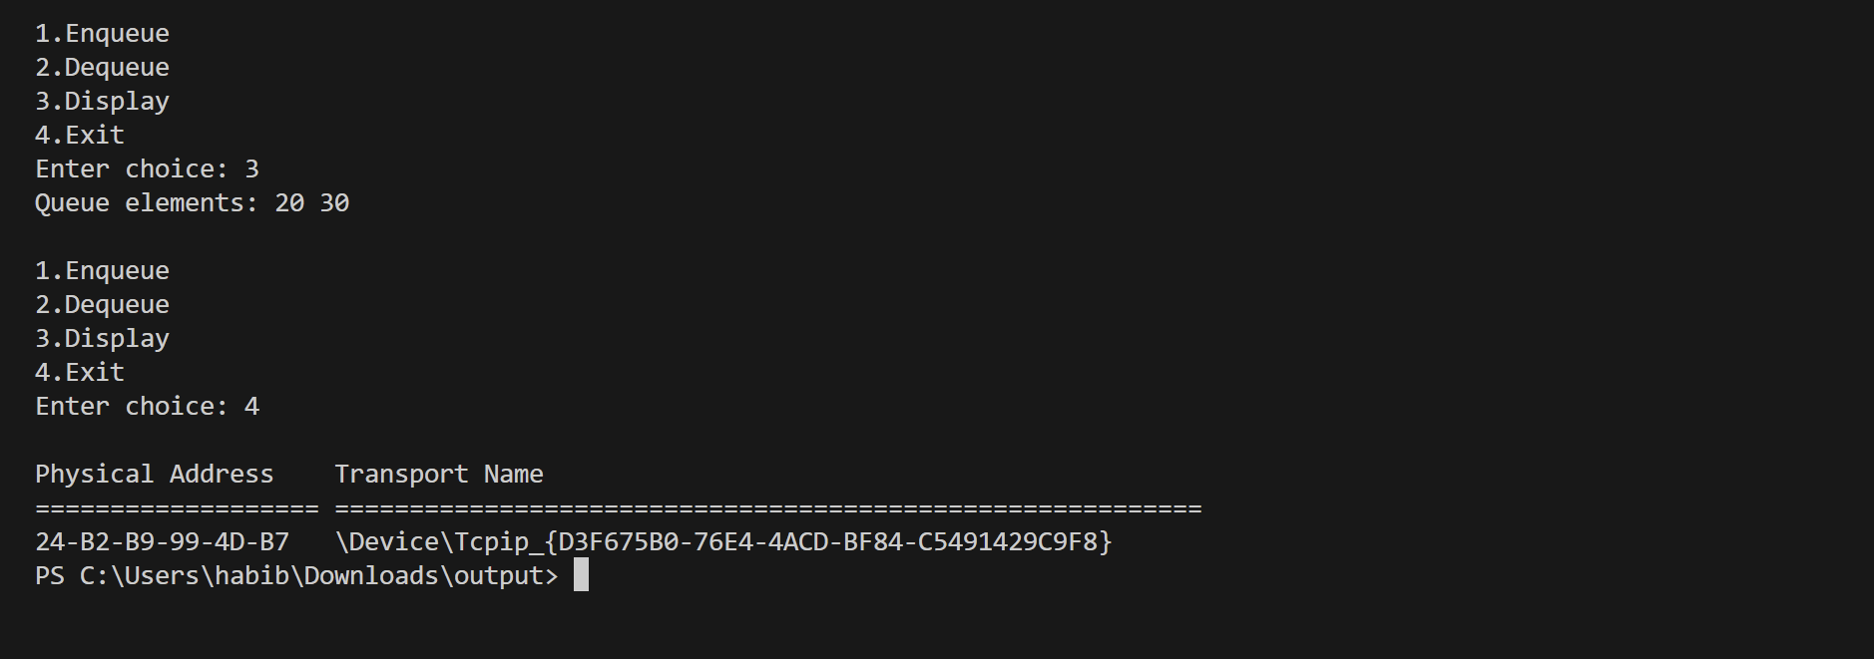

Program:32
#include <stdio.h>
#include <stdlib.h>
struct node {
int row, col, val;
struct node *next;
};
struct node* createNode(int r, int c, int v) {
struct node* n = (struct node*)malloc(sizeof(struct node));
n->row = r;
n->col = c;
n->val = v;
n->next = NULL;
return n;
}
int main() {
int rows, cols, i, j, x;
struct node *head = NULL, *temp = NULL, *newNode;
printf("Enter number of rows and columns: ");
scanf("%d %d", &rows, &cols);
printf("Enter matrix elements:\n");
for (i = 0; i < rows; i++) {
for (j = 0; j < cols; j++) {
scanf("%d", &x);
if (x != 0) {
newNode = createNode(i, j, x);
if (head == NULL) {
head = temp = newNode;
} else {
temp->next = newNode;
temp = newNode;
}
}
}
}

printf("\nSparse Matrix Representation (Linked List):\n");
printf("Row Col Value\n");
temp = head;
while (temp != NULL) {
printf("%d %d %d\n", temp->row, temp->col, temp->val);
temp = temp->next;
}
system("getmac");
return 0;
}
Output:
